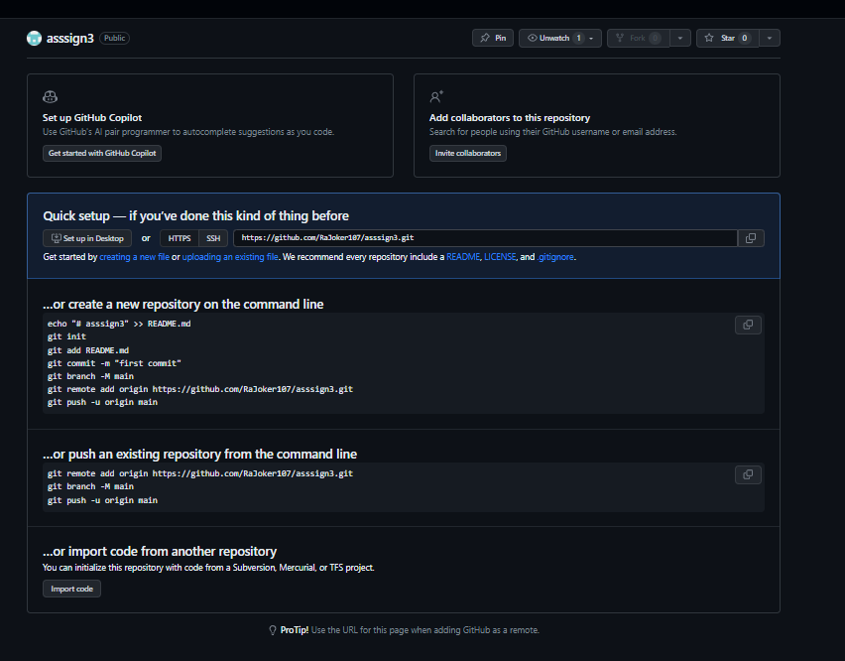

The most similar command is

add

teraj@LAPTOP-RE7U8D56 MINGW64 ~/Desktop/html (master)

$ git add

Nothing specified, nothing added.

hint: Maybe you wanted to say 'git add .'?

hint: Turn this message off by running

hint: "git config advice.addEmptyPathspec false"

teraj@LAPTOP-RE7U8D56 MINGW64 ~/Desktop/html (master)

$ git status

On branch master

No commits yet

Changes to be committed:

(use "git rm --cached <file>..." to unstage)

new file: Pra 2/datalist.html

new file: Pra 2/datalist.js

new file: Pra 2/index.html

new file: Pra 2/script.js

new file: Untitled-1.txt

new file: asiign1 .html

new file: assign2 .html

new file: img/final.jpeg

new file: index.html

new file: raj.html

new file: style.css

teraj@LAPTOP-RE7U8D56 MINGW64 ~/Desktop/html (master)

$ git commit -m "first commit"

Author identity unknown

*** Please tell me who you are.

Run

git config --global user.email "you@example.com"

git config --global user.name "Your Name"

to set your account's default identity.

Omit --global to set the identity only in this repository.

fatal: unable to auto-detect email address (got 'teraj@LAPTOP-RE7U8D56.(none)')

teraj@LAPTOP-RE7U8D56 MINGW64 ~/Desktop/html (master)

$ git remote add origin https://github.com/RaJoker107/asssign3.git

teraj@LAPTOP-RE7U8D56 MINGW64 ~/Desktop/html (master)

**$ git push -u origin master**

Enumerating objects: 46, done.

Counting objects: 100% (46/46), done.

Delta compression using up to 8 threads

Compressing objects: 100% (44/44), done.

Writing objects: 100% (46/46), 1.01 MiB | 1.03 MiB/s, done.

Total 46 (delta 0), reused 0 (delta 0), pack-reused 0

To https://github.com/alok-ahirrao/assignment1.git

* [new branch] master -> master

branch 'master' set up to track 'origin/master'